Engineering & Technology (E&T)

CTO University Engagement (UE) - RESEARCH

Independent Research and Development (IRAD)

**Computational Models for Operationally Relevant Predictions of Humans (CMORPH)**

**Progress Report**

**Date of submission:** July 2024

**Technical Point of Contact:**

Ana Diaz Artiles, PhD

Principal Investigator

Assistant Professor, Aerospace Engineering Department

Bioastronautics and Human Performance Lab

Department of Aerospace Engineering | Texas A&M University

3141 TAMU | College Station, TX 77843-3141

Ph: +1 (979) 845-1187 | [adartiles@tamu.edu](mailto:adartiles@tamu.edu)

<https://bhp.engr.tamu.edu/>

**Graduate Students**

Hrudayavani Vellore (e-mail: [h.vani@tamu.edu](mailto:h.vani@tamu.edu))

Graduate Students, Aerospace Engineering Department

Bioastronautics and Human Performance Lab

Department of Aerospace Engineering | Texas A&M University

3141 TAMU | College Station, TX 77843-3141

|  |  |  |  |
| --- | --- | --- | --- |
| **DOCUMENT CHANGE/ REVISION LOG** | | | |
| **Change/ Revision** | **Date** | **Description of Change** | **Pages Affected** |
| Baseline | 12/01/2022 | Baseline Issue 12/1/2022– First quarterly report | All |
| 01 | 03/01/2023 | Second quarterly report – Updated the preliminary results of the parabolic flight simulation, proposed operationally relevant scenarios, developed a plan to conduct a sensitivity analysis for hypergravity doses, conducted research on the integration of the respiratory model | 8- |
| 02 | 04/19/2023 | Third quarterly report – Definition of relevant scenarios, redefined method of calculation for the total blood volume and body surface area, definition of athletic individuals | All |
| 03 | 7/31/2023 | Year 1 Report – Definition of final relevant scenarios, redefinition of athletic individuals to incorporate LV contractility, definition of dehydrated individuals, recalculation of input parameters | All |
| 04 | 08/27/2023 | Year 1 Report Revision to include results from 3 more gravitational profiles: Stepwise Decrease, Parabolic Flight, and G- Warm Up. | 24- |
| 05 | 11/30/2023 | Fifth quarterly report – Revisiting externally applied pressure, Initial SpO2 model explained | All |
| 06 | 04/30/2023 | Sixth quarterly report – Simulating the seated individual, Preliminary SpO2 model results | 12- |
| 07 |  | Year 1 Report – Definition of final relevant scenarios, redefinition of athletic individuals to incorporate LV contractility, definition of dehydrated individuals, recalculation of input parameters | 8- |
|  |  |  |  |
|  |  |  |  |
|  |  |  |  |

# Table of Contents

1 Table of Contents 3

2 Executive Overview 5

2.1 Abstract 5

2.2 Research Objectives 5

3 Cardiovascular Model Implemented in this Effort 6

3.1 Selecting a Model Type 6

3.2 Cardiovascular Model Description 7

3.3 Existing Framework for Individualized Cardiovascular Modeling 9

4 Operationally Relevant Profiles 9

4.1 Stepwise Increase 9

4.2 Parabolic Flight 10

4.3 G-Warm up Maneuver 11

5 Initial Database and Data Dictionary 12

5.1 Selection of Output Parameters 12

5.1.1 Systemic Cardiovascular Parameters 13

5.2 Selection of Input Parameters 14

5.2.1 Height and Total Mass 15

5.2.2 Total Blood Volume 16

5.2.3 Body Surface Area 18

5.2.4 Athletic Ability 18

5.2.5 Dehydration 19

5.3 Defining Individuals 19

5.4 Modelling the Warfighter in the Cockpit 21

5.4.1 Simulating the Seated Pilot 21

6 Results 22

6.1 Stepwise Increase Scenario 22

6.1.1 Stepwise Increase: Anthropometric Differences 22

6.1.2 Stepwise Increase: Dehydrated Individuals 25

6.1.3 Stepwise Increase: Effect of Athleticism 27

6.2 Parabolic Flight Scenario 29

6.2.1 Parabolic Flight: Anthropometric Differences 29

6.2.2 Parabolic Flight: Dehydrated Individuals 31

6.2.3 Parabolic Flight: Effect of Athleticism 33

6.3 G-Warm Up Scenario 35

6.3.1 G-Warm Up: Anthropometric Differences 35

6.3.2 G-Warm Up: Dehydrated Individuals 37

6.3.3 G-Warm Up: Effect of Athleticism 39

7 Future Work 41

7.1 Further Model Development 41

7.1.1 Respiratory Model Integration 41

7.1.2 Trauma Condition Integration 41

7.2 Experimental Validation 41

7.3 Learning Algorithm Development 41

8 Publications 42

9 Research Team Members 43

10 References and Citations 44

# Executive Overview

## Abstract

Future 21st Century Security will be a complex integration of multiple technologies, including artificial intelligent (AI) driven autonomy. Human warfighters will always be essential, particularly in critical decision making, but humans have physiological and cognitive limits that must be accounted for. We envision autonomy that can intelligently predict and take actions to help its human teammates when they need it most, ultimately increasing human safety and optimizing mission effectiveness. To do this successfully, we need the ability to accurately identify readiness and performance decrements in humans under a wide variety of situations and operational contexts. For example, to effectively assess the pilot’s state, we must understand that a pilot’s heart rate when flying steady and level will be drastically different from when that same pilot is pulling 5 Gs. Off-nominal measures for an operator sitting at a workstation will vary greatly from the same operator walking or running. Individual differences in physiology can also greatly impact expected readiness and performance measures. A 6 ft, 200-pound, male will have different physiological measurements than a 5.3 ft, 155-pound, female doing the same mission tasks. Advance Technology Laboratories’ (ATL’s) algorithms that drive our human assessment systems are rooted in theory but also need realistic data for testing and evaluation. While there is a basic understanding of expected changes in physiology under varying stressors, available data are largely lab-based and sparse. Collecting new physiological data across a large variety of mission contexts and types of people would be prohibitively expensive and time-consuming. Future human assessment algorithm development efforts would substantially benefit from simulated, representative datasets created through configurable human models. We are building on our prior cardiovascular, metabolic, and other modeling work to create a physiological model tailorable to specific operational mission contexts, personalized input parameters, and certain support equipment. Mission context variations may include varying states of physical activity (e.g., sitting, walking, running), dynamic flight profiles (e.g., varying Gs, acceleration profiles), and additional stress analogs. Personalization variations may include weight, height, various body part segment sizes, and sex, which largely impact key global model parameters such as blood volume and cardiovascular outputs. Support equipment, such as G-suits or other compression garments, may also be represented in the model. Texas A&M University has expertise in modeling metabolic output under varying Gs (1) and cardiovascular output under varying Gs and exercise (2). They also have expertise in understanding which input parameters most impact measurable physiological outputs (3), another important factor in future algorithm design. This effort will progress the current state of human assessment systems, increasing accuracy of human state predictions.

## Research Objectives

The goal of this project is to develop and update computational physiology models of humans under operationally relevant conditions to create representative datasets for use in future human/machine teaming algorithm development. Today, algorithms must be developed using best guess Subject Matter Expert estimates or sparse experimental human data collected under limited conditions. This program will build on prior physiological modeling efforts from the University PI (Prof. Diaz Artiles) centered in the characterization of human physiology in altered gravity environments, and the development of gravitational dose-response curves. The result will be tailorable physiological models that can be used to create representative datasets of human responses during a wide variety of conditions and at larger volumes and lower cost than actual experimental data collections.

The main objective of this project is to develop a novel computational framework capable of capturing individual physiological responses to operationally relevant scenarios to warfighters. We propose to leverage our own modeling framework, which already captures individual responses to altered gravity environments, and expand it to integrate new operational scenarios. The database will include both healthy warfighter population as well as relevant trauma conditions. This effort will contribute to the development of human assessment systems, increasing the accuracy of human state predictions.

# Cardiovascular Model Implemented in this Effort

## Selecting a Model Type

There are various approaches to cardiovascular modeling, each with its advantages, disadvantages, and appropriate uses determined by the required spatial degrees of freedom. A literature review was conducted to determine the ideal model type for our use case. Here we will consider 3D models, 1D models, and 0D models.

In three-dimensional (3D) models, fluid behavior is usually described using the Navier-Stokes (NS) equations for incompressible flows. Due to the geometric and mechanical heterogeneity of the vascular tree, modeling the fluid mechanics of the cardiovascular system is complex. One factor that deeply complicates these models is the fact that the mechanical properties of the vessel wall change depending on the size of the vessel because the larger the artery, the more elastic the walls (8). Therefore, 3D models are limited to localized models that require detailed information about the flow because of their high operational cost (9). This makes 3D modeling useful in clinical use cases to model specific cardiovascular regions in individual patients (10).

One-dimensional (1D) models assume axial symmetry and have only one degree of freedom, which is along the axial direction. They are described by hyperbolic partial differential equations. In 1D models, arteries are modeled as rigid or elastic tubes of tapering diameter. “One of the advantages of 1D modeling is to be able to analyze wave intensity (WI), which is important in evaluating the myocardial and hemodynamic functions” (11).

Finally, zero-dimensional (0D), or lumped-parameter models, “assume a uniform distribution of the fundamental variables (pressure, flow, and volume) within any particular compartment (organ, vessel, or part of vessel) of the model at any instant in time” (12). Thus, these models represent the spatial variation in a highly aggregated manner and ordinary differential equations are used to describe the pressure and flow in each compartment as functions of time (8, 12). The operational cost of lumped parameter modeling is low. Since the objective of our modeling effort is to capture beat-to-beat, short-term hemodynamic responses, a lumped-parameter model is the most appropriate choice.

Lumped-parameter models are represented using hydraulic-electrical analogues. Blood flow is analogous to electric conduction. Similar to how a blood pressure gradient drives blood to flow against hydraulic impedance, a voltage gradient drives current against electric impedance. The continuity equation describes mass conservation for blood flow, similar to Kirchhoff’s current law that conserves current. Poiseuille’s Law governs steady-state momentum equilibrium for fluids, and Ohm’s law governs the steady-state voltage-current relation. By relating blood pressure and flow rate with voltage and current, respectively, we are able to represent friction in blood flow as resistance, R, inertia in blood flow as inductance, L, and vessel elasticity as capacitance, C. We will use these analogies to investigate cardiovascular dynamics as an electrical circuit analysis (12).

## Cardiovascular Model Description

“The peripheral circulation is divided into upper body, renal, splanchnic, and lower body sections on the basis that they receive similar fractions of cardiac output. The superior vena cava and the intra-thoracic and abdominal portions of the inferior vena cava are separately identified, as are the ascending aorta, the brachiocephalic arteries, and the thoracic and abdominal portions of the aorta. The arterio-venous resistances of the four peripheral vascular beds have not been assigned to particular arterial or venous compartments as their properties are representative of the respective microcirculations. The latter are described primarily by their resistive properties and are assumed to exhibit negligible capacitive characteristics. The systemic circulation thus consists of fifteen compartments, each of which requires specification of a resistance, a pressure-volume relation, and an effective anatomical length. The latter will be used to determine the compartments’ hydrostatic pressure components in the erect posture. Since we will neglect gravitational gradients in the anterior-to-posterior direction, the effective anatomical lengths are the projections of the vessel lengths onto the major body axis. Since the entire peripheral vasculature is represented by only four vascular beds, it is important for our later discussion of blood volume and blood flow distribution to be clear about which anatomical structures are assigned to which vascular bed. We assume the upper body compartment to represent the circulation of the head, the neck, and the upper extremities…Furthermore, we assume that one third of the blood supply to the skin and one half of the blood supply to the skeleton occurs in the upper body compartment. The renal compartment represents the kidneys and the adrenal glands. The splanchnic compartment comprises the entire gastro-intestinal tract, one half of the adipose tissue, and one third of the skin. Finally, the leg compartment represents the lower extremities and the pelvic circulation.”(4). A circuit representation of the cardiovascular model used in this effort is shown in **Figure 1**.

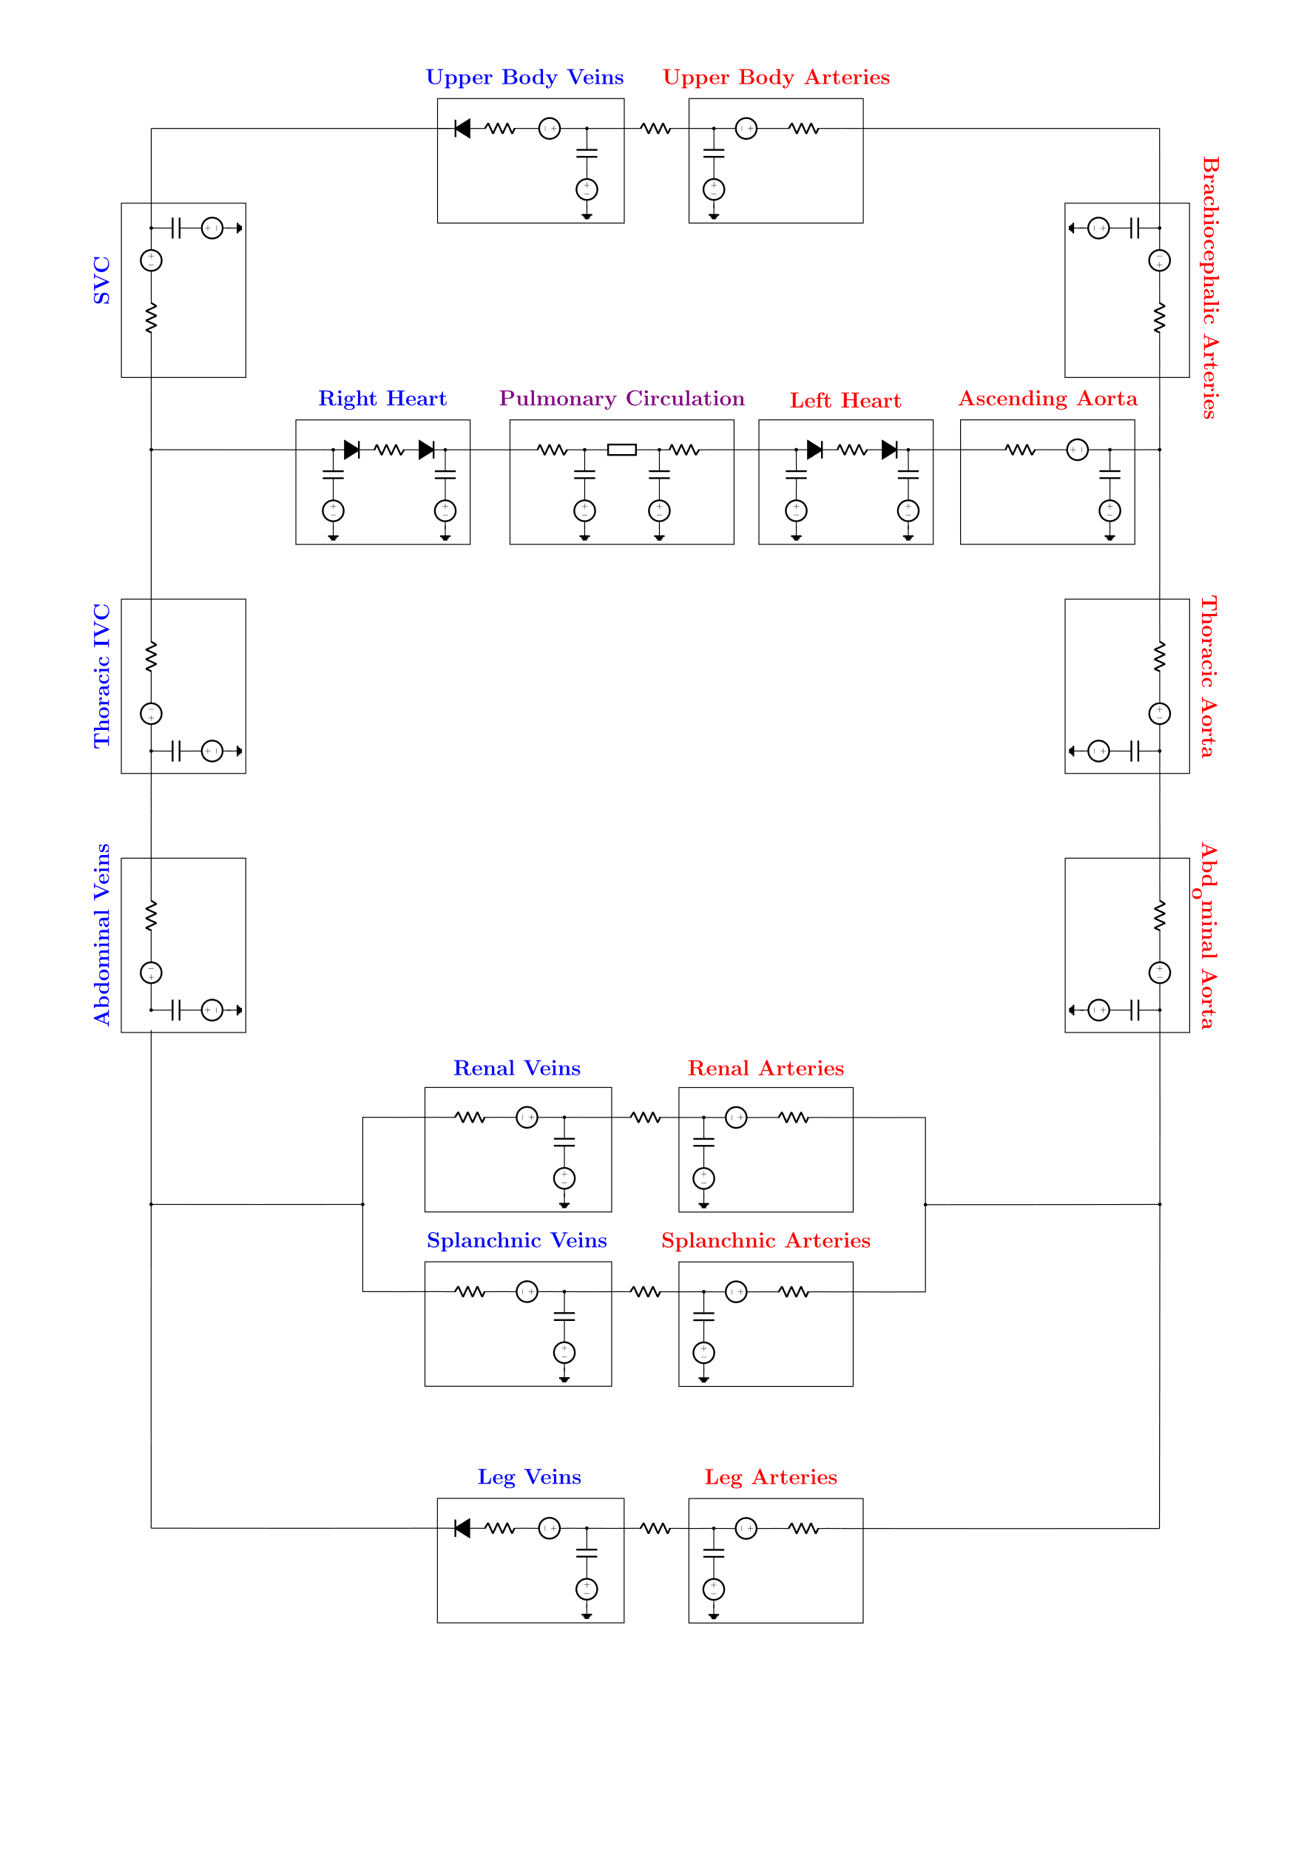

Figure 1 – Circuit representation of the 21-compartment model

## Existing Framework for Individualized Cardiovascular Modeling

We have adapted our model to individual characteristics and extreme environments (e.g., astronauts, fighter pilots). A framework for individualized cardiovascular modeling has emerged in medicine, where physicians are concerned with providing the right treatment to their specific patients. This is known precision medicine or patient-specific medicine (5). To create patient-specific models, individualized patient data and external data must be used. Patient data can include the patient's age, sex, anthropometric measurements, and specific diagnoses. These individualized data are combined with the equations governing the physical processes, based on the spatial degrees of freedom of the model being used. For example, in the context of medicine, individualized models might involve a geometrical representation of a part of a patient’s anatomy (6). We will build on this framework created by medicine to develop our individualized models in the context of human performance in extreme environments. The current literature will prove to be especially helpful when considering the effects of various trauma conditions such as hemorrhage.

# Operationally Relevant Profiles

The following are the operationally relevant scenarios selected to simulate. Each scenario represents a different gravitational profile and allows us to glean information on how different individuals respond to various gravitational loads.

## Stepwise Increase

It is useful to understand an individual’s steady-state response to various gravity levels. The stepwise increase scenario allows us to investigate the response to extended microgravity, hypogravity, normogravity, and hypergravity conditions. The scenario begins with 300 seconds of microgravity. A period of 300 seconds was selected because according to the time constants of the simulation’s control loops, it should produce steady-state values. The first phase of 300 seconds of 0 g is followed by a 1-second transition period up to 0.1 g. The 0.1 g phase is maintained again for another 300 seconds followed by a 1 second transition up to 0.2 g, which is maintained for another 300 seconds. We increase gravity by doses of 0.1 g each time until we reach 2 g. The final 2 g phase is maintained for 300 seconds.

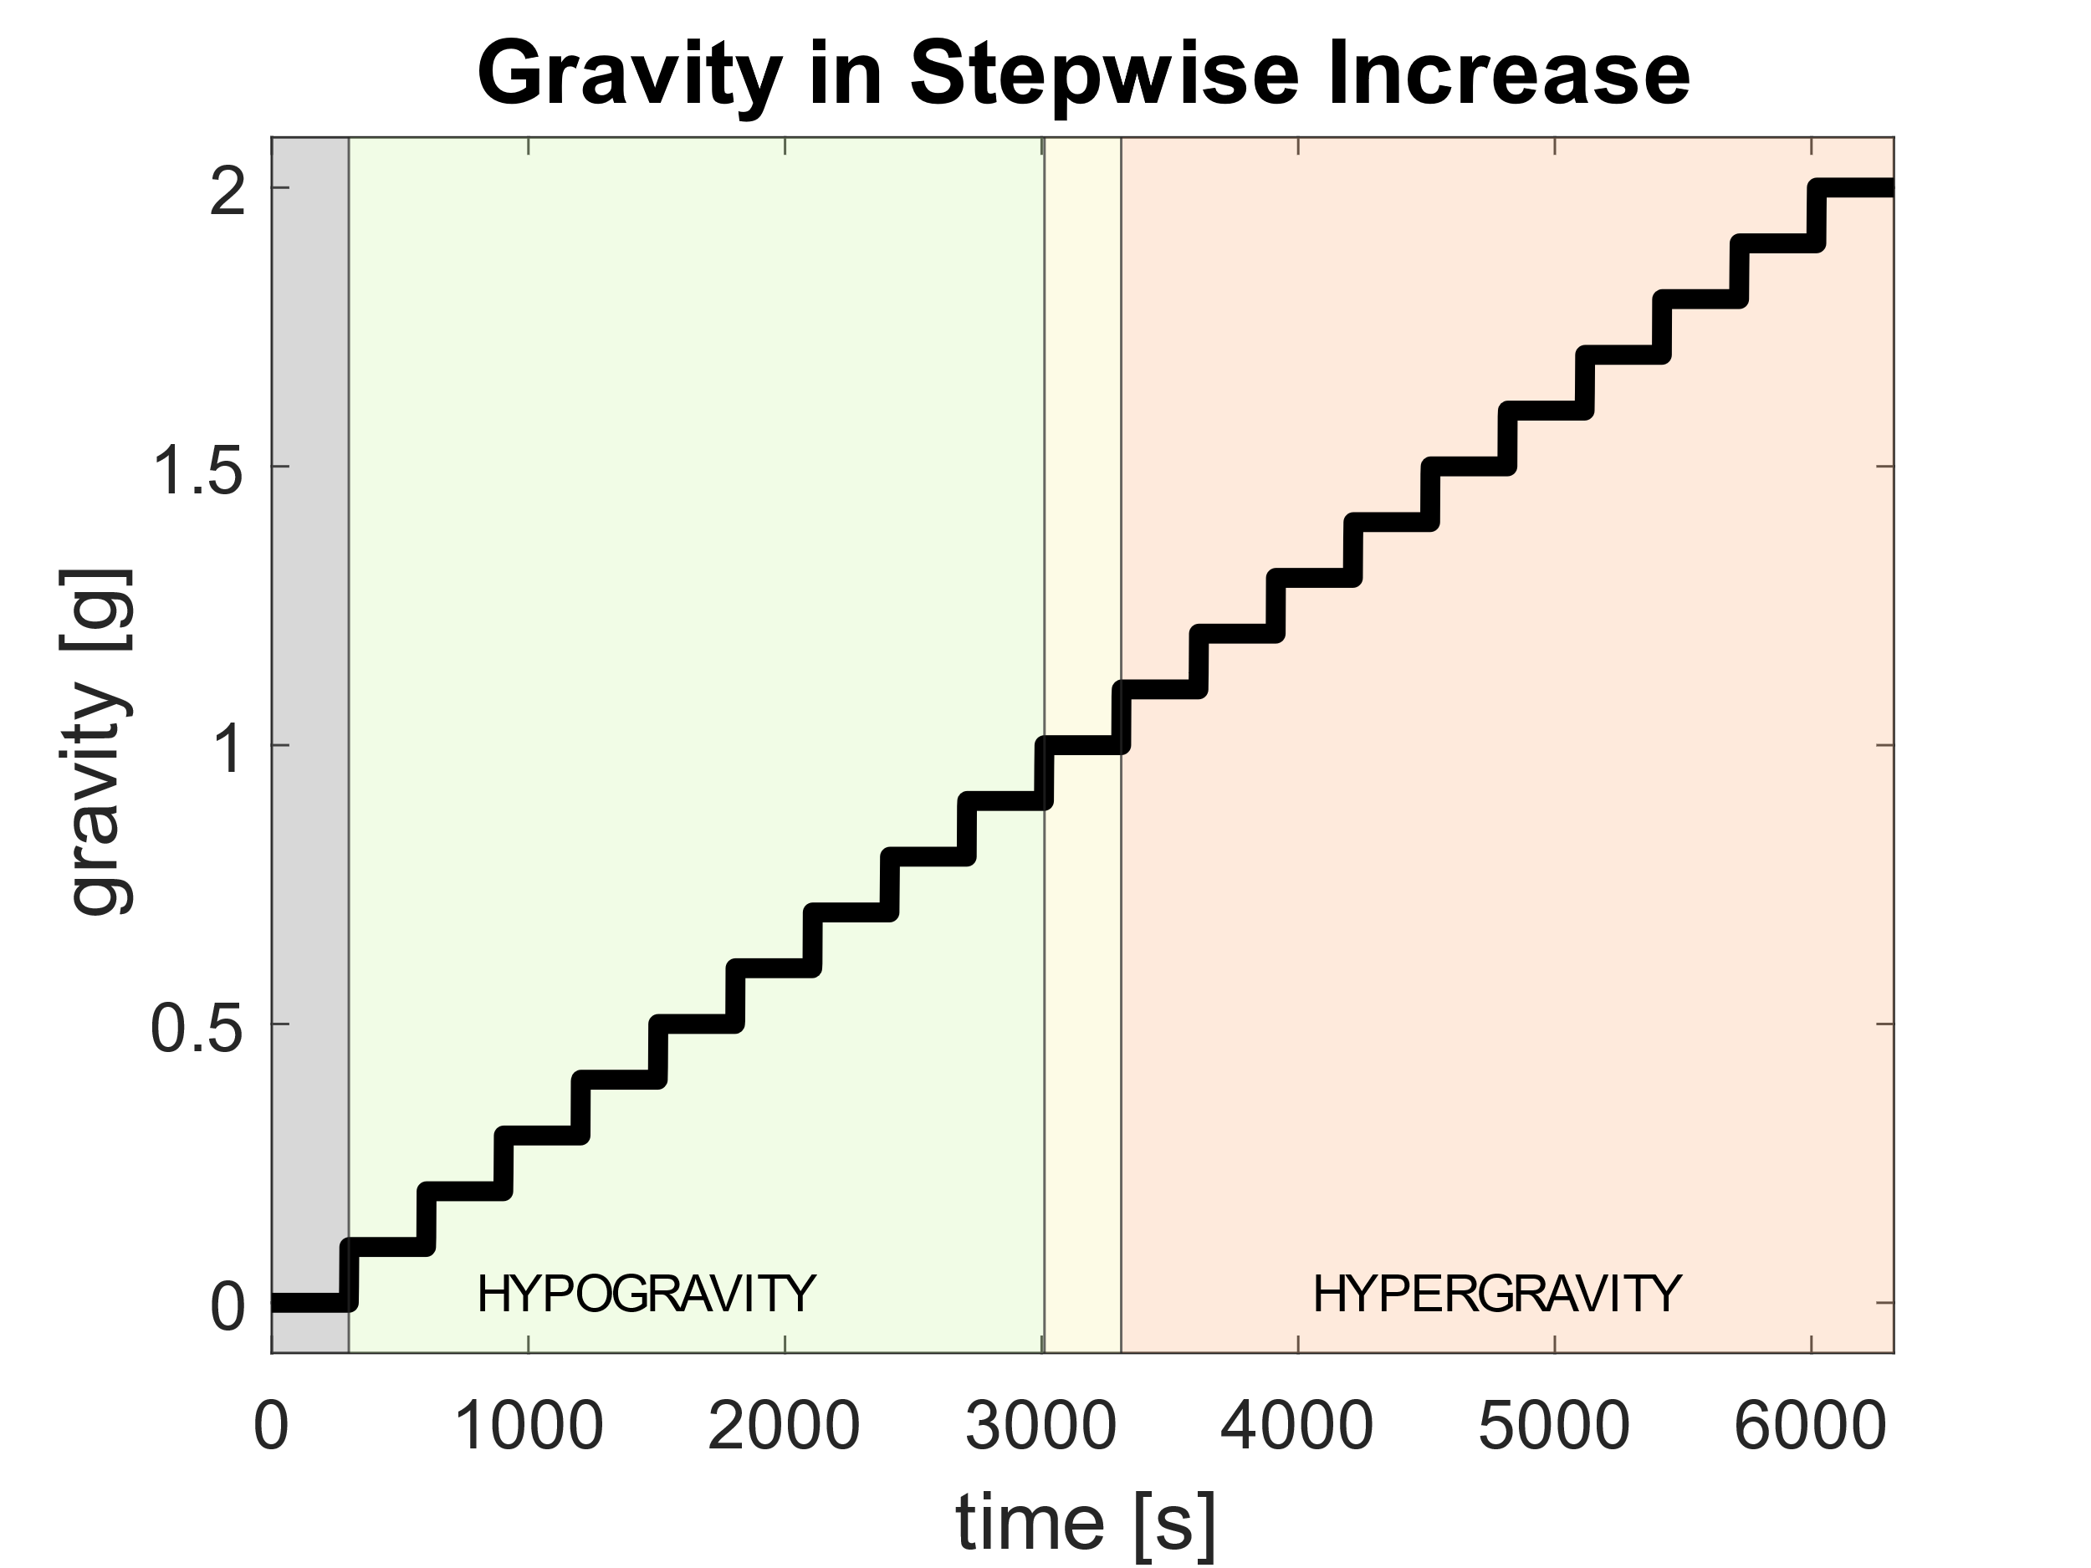

Figure 2 - Gravity profile for a Stepwise Increase maneuver.

## Parabolic Flight

Parabolic flight maneuvers have been used for decades to investigate aspects of physiological function (7). They are particularly useful for our project because they provide short-term changes in gravity dose that mimic those experienced by fighter pilots.

The initial phase consists of 20 seconds of 1 g followed by a 1 second transition period to 1.8 g. The hypergravity phase lasts for 20 seconds followed by a 1 second transition period down to 0 g. Then, 20 seconds of microgravity is followed by a transition into another 20 seconds of 1.8 g. The final phase consists of 20 seconds of 1g. The profile is depicted below.

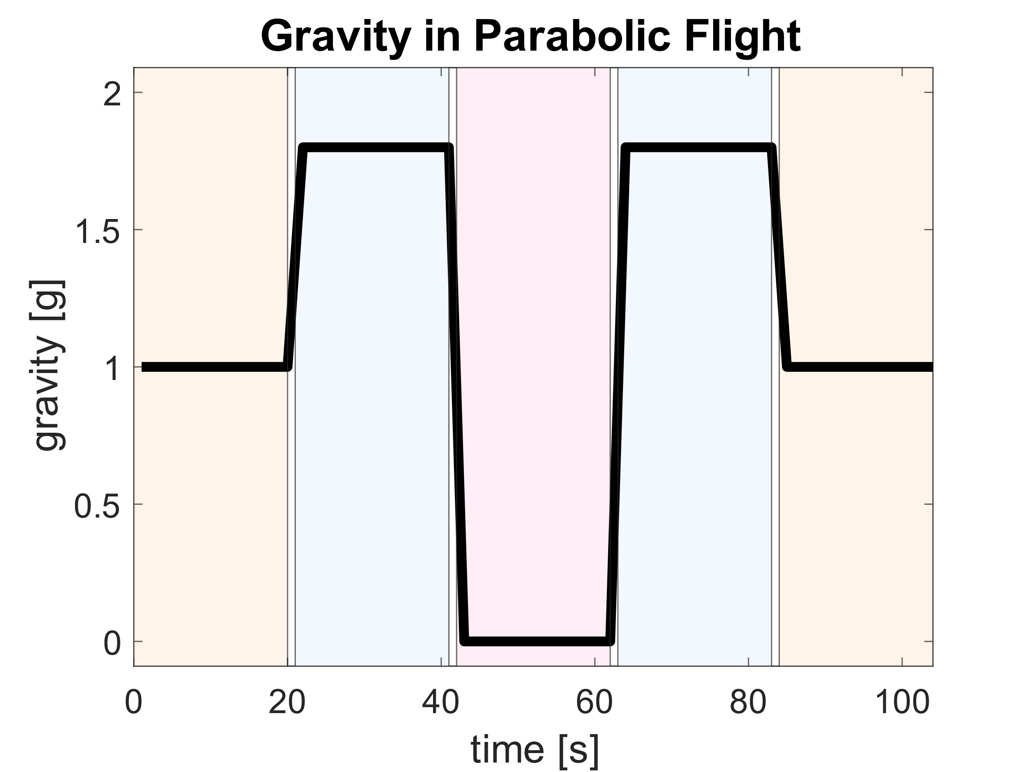

Figure 3 - Gravity profile for a Parabolic Flight maneuver.

## G-Warm up Maneuver

This profile simulates a pilot performing a simple G-Warm Up maneuver, either as part of training or as a “FENCE-in” to a designated area of operations. The profile simulates a smooth transition to a 3 g pull in a 180 degree horizontal level turn, repeated in both the left and right directions. This maneuver is experienced by the pilot in the Gz direction. Thus, the profile consists of a ramp up from 1g to 3g over 3 seconds, sustained 3 g for 10 seconds, followed by a ramp down to 1g over 3 seconds. This is followed by a 5-second break at 1 g and then a repeat of the maneuver. The G-Warm Up profile is depicted below.

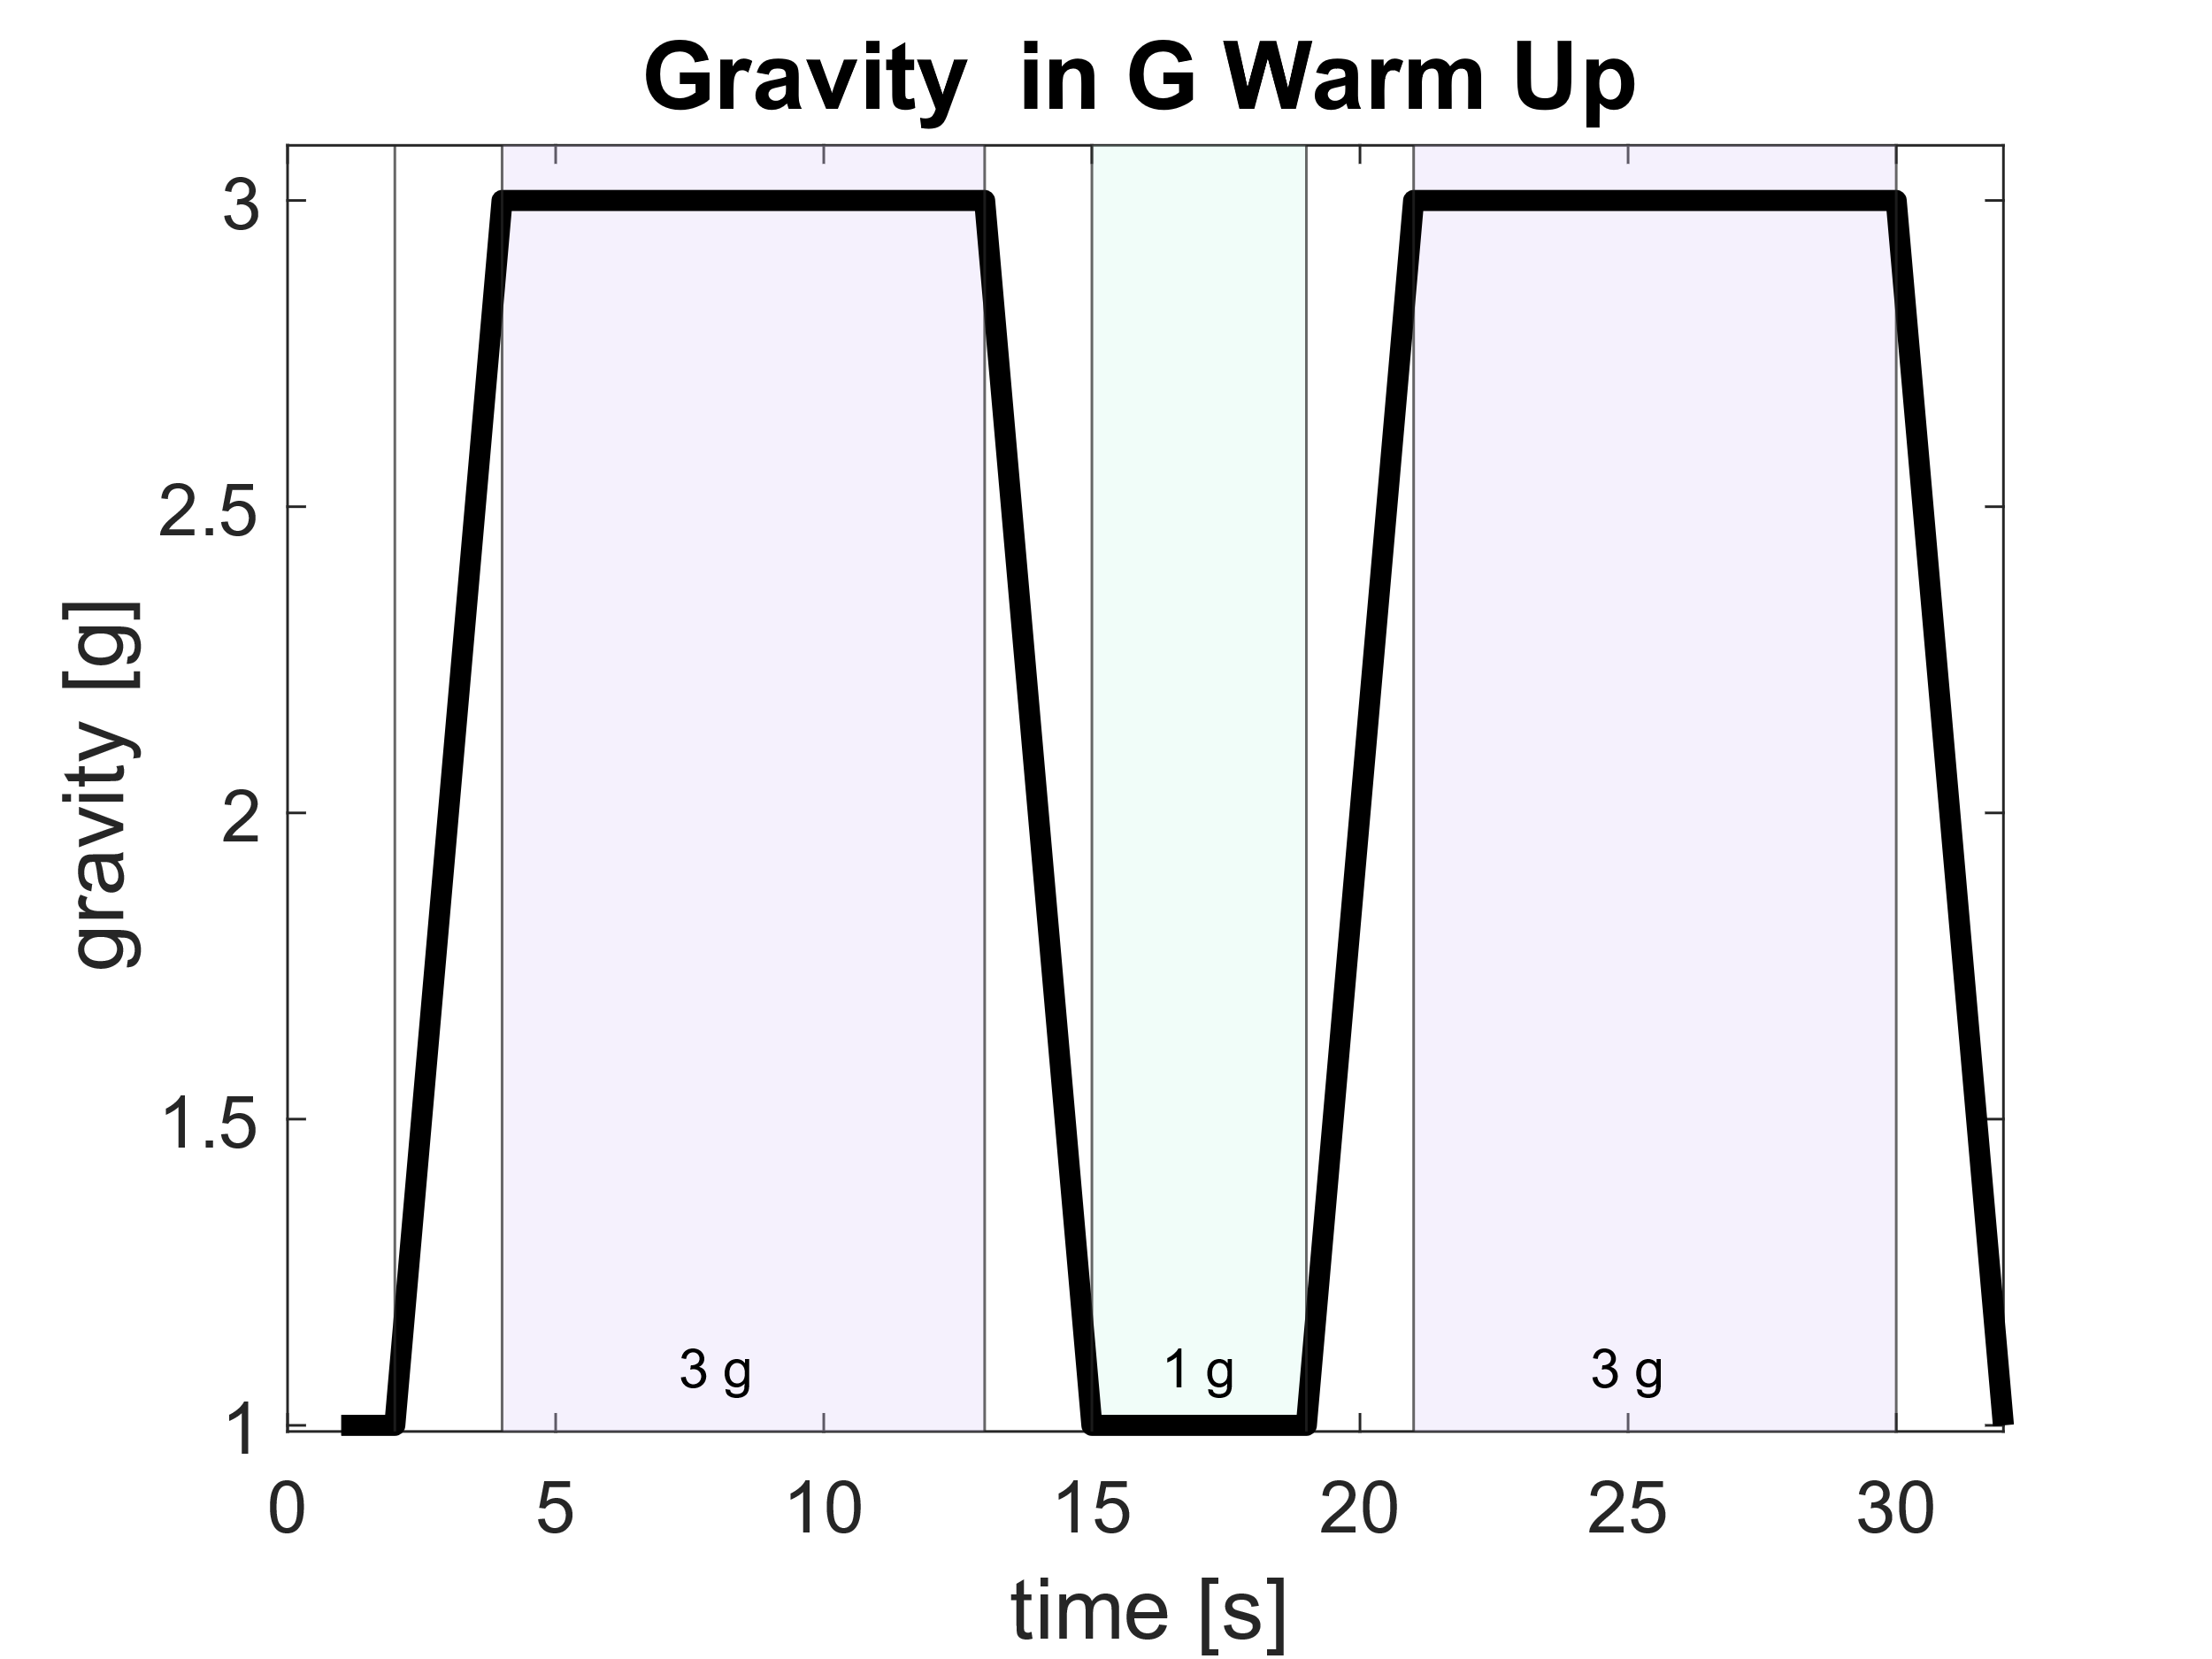

Figure 4 - Gravity profile for a G-warmup maneuver.

# Initial Database and Data Dictionary

## Selection of Output Parameters

A great number of parameters can affect one’s cardiovascular response to various stimuli. The focus stimulus of this research effort is gravity. The physiological and subsequent operational consequences of exposure to high gravity levels due to acceleration has been well documented (see **Figure 6**). Between 1982 and 2002, 479 G-related physiological incidents occurred (8). In spite of advances to anti-G protection technology and new training programs, “the incidence of G-related physiological incidents has remained relatively stable at approximately 30.2 mishaps reported per year from 1998 to 2003”(8) in the United States Air Force. After a literature review, the parameters of interest most commonly collected during experiments can be split into the following categories:

1. Systemic Cardiovascular Parameters
   1. Heart Rate (HR)
   2. Stroke Volume (SV)
   3. Cardiac Output (CO)
   4. Cardiac Index (CI)
   5. Diastolic Blood Pressure (DBP)
   6. Systolic Blood Pressure (SBP)
   7. Mean Arterial Pressure (MAP)

This report will focus on Systemic Cardiovascular Parameters and Heart Rate Variability. There are plans to integrate the respiratory model.

Figure 5 - Visualization of G-force and blood flow direction resulting from pulling out of a dive (a) or pushing into a dive (b). Adapted from " Riding (High) into the danger zone: a review of potential differences in chemical exposures in fighter pilots resulting from high altitude and G-forces," by Linakis et al., 2017, Expert Opinion on Drug Metabolism & Toxicology, 13, NO. 9, p. 929. (9)

### Systemic Cardiovascular Parameters

The systemic cardiovascular parameters include heart rate (HR), stroke volume (SV), cardiac output (CO), cardiac index (CI), diastolic blood pressure (DBP), systolic blood pressure (SBP), and mean arterial pressure (MAP).

The 3 axes of gravity are shown in **Figure 7** below. The +Gz axis describes the direction from the head to the toe and fluid flow in this direction is the main concern of the occupational medicine in this context. Hypergravity forces the blood to pool in the lower body. This fluid shift directly affects the arterial blood pressures. “If the magnitude of the G force surpasses the tolerance of the human body, pilots experience stagnant hypoxia and even suffer from G-induced loss of consciousness (GLOC). While incapacitated, pilots have no control over their plane, and the consequences of GLOC could be tragic” (10). Thus, understanding the effects of gravity on blood pressure is vitally important.

Figure 6 - Adapted from Acceleration in Aviation: G-Force. (11)

Systolic Blood Pressure (SBP) is defined as the peak pressure of the aortic pulse. Shortly following the point at which SBP is measured, a notch occurs, called the dicrotic notch or incisura. Following the dicrotic notch there is an increase in pressure called the dicrotic wave. Then pressure falls to the minimal pressure which is DBP (12). MAP is calculated using the equation below:

$$MAP= \frac{DBP}{3 \left(SBP-DBP\right)}$$

Cardiac output (CO) is an important physiological parameter because it reflects the metabolism of the entire human. “CO is the sum of the systemic flow per minute and calculated by the product of stroke volume and heart rate” (13). The ability of the human body to adapt its metabolism is a direct result of the heart’s ability to increase HR and SV and therefore, CO. CI is CO indexed by body surface area (13). CI is being included as well as CO to further personalize the model.

## Selection of Input Parameters

In the context of the human warfighter, it is vital to understand intraindividual differences in response to gravitational stresses. The following are some input parameters we are taking into account to define our individuals:

* Height
* Weight
* Total Blood Volume (TBV)
* Body Surface Area (BSA)
* Athletic ability
* Hydration

### Height and Total Mass

Height is expected to change cardiovascular response. Heart rate (14) and heart rate variability (15) are known to be affected by height (14, 15). Height is also a simple measure to collect so when the data produced here are used in the future to develop and fly a system to assist pilots, obtaining this input parameter to further individualize their experience will be simple.

Height and total mass were collected from a 2012 anthropometric study of U.S. Army personnel (16). This dataset was selected due to its abundance of anthropometric measurements and the population from which the data was collected. The data were collected from a population of warfighters, which is the population of interest for this research effort. The survey also collected in-depth anthropometric measurements that were directly translatable to the computational model. The exact measurements used are documented in Table 1. Figure 8 displays the parameters pulled from Gordon et al. (16) used to individualize the model.

Figure 7 – Diagram m displaying the parameters pulled from a 2012 anthropometric study of U.S. Army personnel (16) to individualize the model.

### Total Blood Volume

In 1977, Feldschuh et al. (17) conducted a study comparing various methods of estimating TBV. Using a sample of 80 women and 80 men, they tested methods derived from body weight and surface area and a method that uses the deviation from a desirable weight as a factor. A graphic relationship between the ideal weight and height is shown in **Figure 8.**

Figure 8 - Graphic representation of the relationship between ideal (desirable) weight and height developed from The Metropolitan Life Insurance Co. Desirable Weight tables. The upper curve refers to men, the lower curve to women. Adapted from “Prediction of Normal Blood Volume,” by Feldschuh et al., 1977, Circulation, 56(4), p. 606. (17)

The study then found a nonlinear regression between the deviation from the ideal weight, which was calculated a percentage change from the actual weight. This regression, shown in **Figure 9**, will be used to find the blood volume per kilogram of mass per individual. This ratio will be multiplied by the total mass of the individual to find TBV. To reiterate, this means that a female and a male with the same height and weight will have a different TBV.

Figure 9 - Graphic representation of the relationship between the ratio of blood volume to body weight, on the ordinate in ml/kg and deviation from ideal (desirable) weight assessed from Figure 8 on the abscissa in percent. One hundred eighty-eight observations in 80 normal women (circles) and 80 normal men (triangles) are included. Adapted from “Prediction of Normal Blood Volume,” by Feldschuh et al., 1977, Circulation, 56(4), p. 606.

Figure 11 displays the order of individuals from largest to smallest based on TBV. This will be used in Section 5 to compare physiological responses in altered gravity between individuals. PCTL indicates percentile.

Figure 10 - All anthropometrically different individuals ordered from largest to smallest based on TBV.

### Body Surface Area

Body Surface Area (BSA) was calculated because is necessary to calculate cardiac index (CI). BSA is an important parameter in many fields of study, including pharmacology, and physiology. However, measuring BSA is very difficult due to the complex architecture of the human body.

The estimates we will be using are from a 2001 study by Tikuisis et al. They utilized 3D laser scanning technology and reported on two different formulas for BSA distinguishing by sex (18).

$$BSA=147.4*m^{0.47}*h^{0.55} \left(females\right)$$

$$BSA=128.1*m^{0.44}*h^{0.60} \left(males\right)$$

### Athletic Ability

Athletic ability greatly affects certain baseline cardiovascular parameters, the extent to which is vast and depends on the type of conditioning each individual has been subject to.

First, we will discuss cardiac remodeling starting with left ventricle (LV) enlargement. The impact of training on LV structure has been the topic of extensive study for decades. “Pelliccia et al. (19) reported echocardiographic LV end-diastolic cavity dimensions in a large group (n=1309) of Italian elite athletes. This cohort was made up predominantly of male athletes (73%) and included individuals from 38 different sports. Left ventricular end-diastolic diameters varied widely, from 38 to 66 mm in women (mean, 48 mm) and from 43 to 70 mm in men (mean, 55 mm). Importantly, LV end-diastolic diameter was ≥54 mm in 45% and >60 mm in 14% of the cohort. Markedly dilated LV chambers (>60 mm) were most common in athletes with higher body mass and those participating in endurance sports (cycling, cross-country skiing, and canoeing).”(20)

Resting HR following endurance training is also lower according to the same study. The results for both LV dimension (translated to LV ZPFV) and baseline (or resting) HR of high endurance athletes are used to specify the individuals.

After running some simulations, this was proved. It is therefore necessary to specify athleticism with another parameter: the contractility of the left ventricle. It is understood that LV contractility (and its inverse, elasticity) are altered with exercise (21). As contractility improves with exercise, we aimed to find the lowest LV contractility from a study of healthy individuals. The value chosen is specified in **Table 3** was selected from Starling et al (22).

### Dehydration

Dehydration decreases plasma volume and TBV (23). This results in a decreased SV and increased HR. This prevents a significant decline in CO (24). To simulate dehydration, TBV was decreased by 9.6% in accordance with the results from Dill and Costill (25). It is understood that altering TBV alters many parameters of cardiovascular response to altered gravity (3) so it comes to reason that a simulated state of dehydration will do the same.

## Defining Individuals

The individuals simulated were chosen to create a database of a wide variety of individuals. Specifics on how Total Blood Volume (TBV) and Body Surface Area (BSA) are chosen is discussed in detail in the previous section. The Zero Pressure filling volume (ZPFV) of each compartment was altered proportionally to the change in TBV for each individual. To simulate dehydration, TBV was decreased by 9.6% in accordance with the results from Dill and Costill (25). In the table below, the green highlighted area signifies the parameters that are different for that individual when compared to the 50th PCTL F and 50th PCTL male.

Table 1 – Input parameters for the 5th percentile (PCTL) Female (F), 5th PCTL Male (M), 50th PCTL F, 50th PCTL M, 95th PCTL F, 95th PCTL M, 50th PCTL Dehydrated F, 50th PCTL Dehydrated M, 50th PCTL Athletic F, and 50th PCTL Athletic M.

|  |  |  |  |  |  |  |  |  |  |  |
| --- | --- | --- | --- | --- | --- | --- | --- | --- | --- | --- |
| Parameters | 5th PCTL F | 5th PCTL M | 50th PCTL F | 50th PCTL M | 95th PCTL F | 95th PCTL M | 50th PCTL Dehydrated F | 50th PCTL Dehydrated M | 50th PCTL Athletic F | 50th PCTL Athletic M |
| TBV [mL] | 3642.3 | 4508.0 | 4275.2 | 5499.0 | 5051.8 | 6586.7 | 3864.8 | 5050.3 | 4275.2 | 5499.0 |
| BSA [m2] | 1.490 | 1.730 | 1.747 | 2.036 | 2.054 | 2.392 | 2.054 | 2.392 | 1.747 | 2.036 |
| Baseline HR [bpm] | 73.2 | 70.3 | 73.2 | 70.3 | 73.2 | 70.3 | 73.2 | 70.3 | 69.5 | 65.4 |
| Height [cm] | 152.5 | 164.8 | 162.6 | 175.5 | 174.0 | 187.0 | 174.0 | 187.0 | 162.6 | 175.5 |
| Total Mass [kg] | 51.3 | 64.4 | 66.8 | 84.6 | 87.1 | 110.7 | 87.1 | 110.7 | 66.8 | 84.6 |
| Height of Head [cm] | 22.0 | 23.3 | 24.0 | 25.4 | 26.0 | 27.5 | 26.0 | 27.5 | 24.0 | 25.4 |
| Upper Arm Length [cm] | 28.3 | 30.7 | 31.1 | 33.5 | 34.0 | 36.5 | 34.0 | 36.5 | 31.1 | 33.5 |
| Forearm Length [cm] | 21.8 | 24.4 | 24.0 | 24.4 | 26.8 | 29.5 | 26.8 | 29.5 | 24.0 | 24.4 |
| Seated Leg Length [cm] | 73.2 | 78.0 | 79.4 | 84.7 | 86.0 | 91.7 | 86.0 | 91.7 | 79.4 | 84.7 |
| Tibial Height [cm] | 39.9 | 42.6 | 43.7 | 46.7 | 47.9 | 51.3 | 47.9 | 51.3 | 43.7 | 46.7 |
| Left Ventricle ZPFV [mL] | 45.3 | 51.2 | 49.8 | 55.9 | 49.8 | 55.9 | 49.8 | 55.9 | 54.8 | 59 |
| LV Contractility [cm] | 0.4 | 0.4 | 0.4 | 0.4 | 0.4 | 0.4 | 0.4 | 0.4 | 0.15 | 0.15 |
| Vm titlt [mL] | 247.5 | 306.4 | 290.6 | 373.7 | 343.3 | 447.6 | 290.6 | 373.7 | 290.6 | 373.7 |

## Modelling the Warfighter in the Cockpit

Individual differences in physiology can greatly impact expected readiness and performance measures. We created physiological models that are tailorable to specific operational mission contexts and personalized to different individual characteristics. As all pilots are seated in the cockpit, we had to simulate the individual as seated. We have defined three potentially relevant scenarios, outlined below. All act in the Gz direction. For these scenarios, we aim to simulate gravity profiles that a warfighter population may be exposed to during the course of their operational duties. These scenarios are designed to be somewhat airframe agnostic, and the exact specifics can be adjusted as necessary.

### Simulating the Seated Pilot

Figure 11 – Positions of anthropometric parameters used to define the seated position.

The seated position was simulated fourfold: reduced leg compartment lengths, 30 degree tilt back, reduced interstitium volume, and applied lower limb external pressure. Firstly, the lengths of the lower limb compartments were shortened to be the sum of two times the radius of the thigh and the height of the shin. This total leg compartment length reflects the effective length of the legs when seated as it does not include the length of the thigh. Shortening the leg compartment lengths reduces the magnitude of the effect of gravity on the output parameters. For example, shortening the leg compartments during the parabolic flight maneuver decreases the maximum SV reached during the 0 g phase for the 50th PCTL male.

The next component used to simulate the seated position of a pilot in a high-performance aircraft is to tilt all simulated individuals back 30◦ from upright. In the Gz axis the vertebral column is the part of the musculoskeletal system that experiences the most severe stress during hypergravity phases, therefore high-performance aircraft have seats that are reclined back to support the neck and reduce spinal injuries and neck pain (26–28). The seat back angle disperses the high Gz forces, therefore reducing the load on the spinal column. The 30 degree tilt back chosen in all simulations reflects the recline of an F-16 (26–28). The tilt-back when compared to the upright seated position reduced the effect of gravity on the output parameters because the effective gravity vector in the head-to-toe direction has been reduced.

Diaz Artiles (29) and Zamanian (30) allowed a maximum of 350 mL of fluid to be lost to the interstitium due to tilt (Vm tilt). For each individual, this value was changed proportionally according to TBV. All individual Vm tilt values are in Table 1.

Finally, to simulate the compression on the lower body while seated, external pressure (Pext) was applied to the lower limb compartments. The magnitude of the Pext must be dependent on gravity level and anthropometrics. Greater pressure is required to counteract the greater foot-ward fluid shift caused by higher gravity loads, and anthropometrically larger individuals need greater Pext to counteract the greater foot-ward fluid shift. The equation below is based on the hydrostatic pressure equation, which allows Pext to vary based on gravity load and anthropometrics. In Equation 4.6, ρfat−free tissue is the density of fat-free tissue (1.10g/cm3), g is the gravity level, hupper body is the height of the upper body and rthigh is the radius of the thigh as shown in Figure 12.

$$P_{ext}\left[mmHg\right]=ρ_{fat-freetissue}*g*\frac{2}{3}\left(h_{upperbody}+r_{thigh}\right)$$

# Results

## Stepwise Increase Scenario

The stepwise increase scenario was designed to study the steady-state cardiovascular response of all individuals between 0 g and 2 g. Figure 3 shows the exact gravity profile simulated. In the following plots, the areas highlighted in grey indicate microgravity, areas highlighted in green indicate hypogravity, areas highlighted in yellow indicate normogravity (i.e., 1 g), and areas highlighted in orange indicate hypergravity.

### Stepwise Increase: Anthropometric Differences

Figure 12 shows the cardiovascular response to the stepwise increase scenario specifically highlighting anthropometric differences. We can see distinctive differences in response from each simulated individual across all the cardiovascular parameters, thus showcasing the importance of this project. Overall, as gravity increases so does HR. Regarding anthropometric differences, smaller individuals have a higher HR across all gravity phases. The individual with the greatest HR in all gravity phases is the smallest individual according to Figure 11: the 5th PCTL female. The individual with the next greatest HR in all gravity phases is the second smallest individual: the 50th PCTL female. The individual with the lowest HR in all gravity phases is the largest individual: the 95th PCTL male. The difference between the 5th PCTL female and the 95th PCTL male at the start of the scenario is 18.13 bpm. At the end of the scenario, this difference is 28.05 bpm.

Overall, as gravity increases, SV decreases. For some individuals, in the early hypogravity phase between 0.3 g and 0.5 g, SV increases at the onset of a new gravity phase but decreases over the course of those gravity phases. These few gravity transitions are the exception to the trend. In general, the larger individuals have greater SV. The individual with the greatest SV in all gravity phases is the largest individual: the 95th PCTL male. The individual with the lowest SV in all gravity phases is the smallest individual: the 5th PCTL female.

For all simulated individuals, as gravity increases, CO decreases. This relationship does not appear to be linear. A similar dip in CO can be observed between 0.3 g and 0.5 g. This is to be expected because CO is the effective product of HR and SV, and a similar dip can be observed in SV. The anthropometrically larger individuals tend to have greater CO when compared to the anthropometrically smaller individuals, but this is not a perfect trend. The largest individual is the 95th PCTL male. His CO is greater than all the other COs from the rest of the individuals in all gravity phases. The smallest individual (the 5th PCTL female) has the lowest CO in all gravity phases. Similarly to CO, as gravity decreases, CI decreases. Again, this relationship does not appear to be linear. The 5th PCTL female has the greatest CI for most gravity phases. The individual with the next greatest CI is the 5th PCTL male, then the 50th PCTL female, then the 95th PCTL female, then the 50th PCTL male, then finally the 95th PCTL male. This order represents exactly the order from the anthropomorphically smallest individual to the anthropometrically largest individual according to Table 4.1. By normalizing CO by BSA, the slight mismatch in the order of responses observed in the responses for CO disappears. That is to say, as body size increases, CI decreases in a direct relationship.

Within the blood pressure measures, we must distinguish the response in hypogravity, and the response in hypergravity. As gravity increases from 0 g to 1 g, DBP increases in hypogravity for all individuals. In hypergravity, DBP initially continues to increase but then begins to decrease. The rate of this decrease is dependent on the individual. We once again see a sharp shift during a gravity transition between 0.3 g and 0.5 g. In hypergravity, SBP decreases. This relationship does not appear to be linear. Experimental data suggests that the body has difficulty maintaining blood pressure in hypergravity (31). Generally, anthropometrically large individuals have a greater SBP in all gravity phases. The smallest individual, the 5th PCTL female consistently has the lowest SBP across all gravity phases. MAP, as a function of SBP and DBP, behaves similarly to 45 both. Generally, the anthropometrically larger individuals have greater MAP and as with SBP, the 5th PCTL female, consistently has the lowest SBP across all gravity phases. In hypogravity, an increase in blood pressure can be seen similar to the DBP, and the sharp shifts are similar to SBP. In hypergravity, expectantly MAP decreases. Once again, we observe that generally, the smaller individuals have lower blood pressure.

Figure 12 - **Cardiovascular response in the stepwise increase scenario highlighting the effect of anthropometric differences.**

### Stepwise Increase: Dehydrated Individuals

Figure 13 shows how dehydration affects cardiovascular response in the stepwise increase scenario. We observe that hydration level does not affect the relationship between any of the cardiovascular parameters and gravity level. For example, HR increases with gravity for the 50th PCTL female and the dehydrated 50th PCTL female. In Figure 13 and all proceeding figures that depict the response of dehydrated individuals, the red line indicates the 50th PCTL female and the lighter red/pink line indicates the dehydrated 50th PCTL female. Similarly, the blue line indicates the 50th PCTL male and the lighter blue line indicates the dehydrated 50th PCTL male. Dehydration increases HR, decreases SV, decreases CO, decreases CI, decreases DBP, decreases SBP, and decreases MAP. The decrease in SV and increase in HR aligns with experimental results (24). The difference between the dehydrated and not dehydrated female at the start of the scenario is 9.97 mmHg. This difference increases to 17.62 at the end of the scenario. For the male individuals, the difference begins at 8.98 mmHg and increases to 14.25 mmHg.

Figure 13 - Cardiovascular response in the stepwise increase scenario highlighting the effect of dehydration.

### Stepwise Increase: Effect of Athleticism

Figure 14 shows how athleticism affects cardiovascular response in the stepwise increase scenario. In Figure 14 and all proceeding figures that depict the response of athletic individuals, the red line indicates the 50th PCTL female and the darker red line indicates the athletic 50th PCTL female. Similarly, the blue line indicates the 50th PCTL male and the darker blue line indicates the athletic 50th PCTL male. Athleticism decreases HR and increases SV in the 50th PCTL male and decreases SV in the 50th PCTL female. The 50th PCTL male has a higher CO and CI in hypergravity and the 50th PCTL female has lower CO and CI compared to their non-athletic counterparts.

DBP, SBP, and MAP for the athletic female is less compared to the non-athletic individual. DBP and MAP in hypergravity do not decrease in hypergravity but continue to increase for the athletic 50th PCTL male. The athletic 50th PCTL male’s SBP does decrease in hypergravity similar to the non-athletic counterpart, but the decrease has a decreased magnitude. The difference in MAP between the athletic female and the not athletic female is 2.86 mmHg at the start of the scenario and increases to 7.78 mmHg at the end of the scenario. The males exhibit a much larger increase. The difference between the athletic male and the not athletic male begins at 0.04 mmHg and increases to 23.89 mmHg at the end of the scenario.

Figure 14 - Cardiovascular response in the stepwise increase scenario highlighting the effect of athleticism.

## Parabolic Flight Scenario

The parabolic flight maneuver was chosen as a simulation scenario because of the availability of experimental data to compare to our simulated data to verify it. This analysis is done in the associated thesis (32). This section presents the instantaneous response curves of all the individuals in parabolic flight. Whereas the last scenario had periods of sustained hypo and hypergravity, the parabolic flight scenario has much shorter 20-second phases of microgravity and hypergravity. The plots in this section depict the 1 g phases shaded in orange, the 1.8 g phases shaded in blue, and the 0 g phases shaded in pink.

### Parabolic Flight: Anthropometric Differences

The cardiovascular response in the Parabolic Flight scenario highlighting anthropometric differences is shown in Figure 15. It can be observed that HR increases during the first hypergravity phase and then decreases at the onset of microgravity. During the microgravity phase, HR begins to increase and continues to increase into the hypergravity phase in all individuals. At the beginning of the final normogravity phase, HR decreases before increasing trying to achieve the steady state value observed during the first normogravity phase. The anthropometrically smallest individual, the 5th PCTL female, experienced the greatest HR during all phases and the anthropometrically largest individual, the 95th PCTL male, experienced the lowest HR during all phases. The difference in performance among all individuals is the least during microgravity.

SV decreases at the onset of the hypergravity phase and increases at the onset of the microgravity phase before sharply decreasing. At the onset of the second hypergravity phase, SV increases and seems to reach a similar plateau as the first hypergravity phase. There is an increase in SV at the onset of normogravity. The greatest SV is produced by the anthropometrically largest individual and the least by the smallest individual. In general, the anthropometrically smaller individuals have lower SV.

CO and CI have similar responses. There is an initial decrease at the onset of the first hypergravity phase before the values seem to plateau. At the onset of the microgravity phase, both increase sharply before decreasing. The variability in CI among the individuals is the least in microgravity. At the onset of the final hypergravity phase, CO and CI increase again. The amount of this increase in CO is dependent on the individual. At the onset of the final normogravity phase, there is a sharp and shallow decrease in CO and CI.

All pressure curves exhibit the same relationship to gravity phases. DBP, SBP, and MAP all initially decrease then increase in hypergravity and initially increase then decrease in microgravity. The differences between the different anthropometric individuals are minimal for DBP during the initial steady-state normogravity phase. For SBP and MAP, larger individuals tend to have higher blood pressure values. The difference among these anthropometrically different individuals once again diminishes in microgravity.

Figure 15 - Cardiovascular response in parabolic flight highlighting the effect of anthropometric differences.

### Parabolic Flight: Dehydrated Individuals

In Figure 16 the cardiovascular response in the parabolic flight scenario highlighting the effect of dehydration can be observed. Dehydration has the effect of increasing HR in all phases of the scenario. Similarly, SV is decreased in all gravity phases due to dehydration. CO and CI are decreased due to dehydration in all gravity phases. DBP, SBP, and MAP all experience a decrease in most gravity phases due to dehydration. The exception is the last 1 g phase where all responses align closely.

Figure 16 - Cardiovascular response in the parabolic flight scenario highlighting the effect of dehydration.

### Parabolic Flight: Effect of Athleticism

Figure 17 shows the cardiovascular response in the parabolic flight scenario highlighting the effect of athleticism. When the parameters that define athleticism are introduced, HR is decreased for the 50th PCTL male. The female response is not greatly altered by athleticism. In normogravity, the athletic male has a greater SV, and the athletic female has a lower SV. Athleticism decreases CI in all gravity phases except the microgravity phase.

The difference in performance between the athletic and nonathletic individuals is almost identical in all gravity phases for CO, DBP, SBP, and MAP.

Figure 17 - Cardiovascular response in the parabolic flight scenario highlighting the effect of athleticism.

## G-Warm Up Scenario

The G-Warm Up is unique in that it captures gravity transitions in the shortest time frame and is one of the most relevant scenarios for the warfighter. This profile simulates a smooth transition to a 3 g pull in a 180 degree horizontal level turn, repeated in both the left and right directions. This results in g loading experienced by the pilot in the Gz direction. Figure 4 details the gravity profile for this scenario. In the plots depicting cardiovascular response to G-Warm Up, the areas shaded in purple depict the 3 g phase and the areas in mint green depict the 1 g phase.

### G-Warm Up: Anthropometric Differences

Figure 18 shows the cardiovascular response in the G-Warm Up scenario while highlighting anthropometric differences. HR increases during the first hypergravity phase of 3 g. During the 1 g phase, HR decreases in an attempt to reach its steady state normogravity value. During the transition into the second 3 g phase, HR decreases sharply and continues to increase at the onset of the 3g phase. Similar to what was observed in previous scenarios, the anthropometrically smaller individuals generally have higher HR values across all gravity phases and vice versa. We observe that the largest individual, the 95th male, consistently has the lowest HR across all gravity phases. SV decreases during the first 3 g phase when compared to the initial 1 g state and increases during the 1 g phase to a greater value than the steady state 1 g values. During the second 3 g phase, SV decreases again to similar values as the first 3 g phase. Again, we observe that in general, the larger individuals have higher SV in all phases. The largest individual consistently has the highest SV across all gravity phases.

CO and CI have the same trends with respect to gravity. They decrease during the first 3 g phase and increase during the transition to 1 g and into the beginning of the 1 g phase. At the later part of the 1 g phase, CO and CI decrease slightly before increasing sharply during the transition to the second 3 g hypergravity phase. During the final 3 g phase CI and CO both decrease to values similar to those of the first 3 g phase. In general, the larger individuals have greater CO values, but this is not true for CI. The distinction among the individuals is less defined for the CI values when compared to CO. In the initial steady state 1 g phase, CI from greatest to least follows the order of smallest to largest individual exactly but as the G-Warm Up scenario proceeds, this order is not maintained.

The relationship between blood pressure and gravity is the same across all three blood pressure measurements. Blood pressure decreases during the first 3 g phase and begins to increase, this increase is sustained through the transition to 1 g. During the second 3 g phase, blood pressure decreases again. During the transition from 1 g to the second 3 g phase a shallow dip can be observed in DBP. Because MAP is a function of DBP and SBP this pattern can be observed with less magnitude in MAP. For all blood pressure measurements, the individual with the greatest blood pressure across all gravity phases is the 95th PCTL male. Generally, the larger individuals have greater blood pressures across all gravity phases.

Figure 18 - Cardiovascular response in the G-Warm Up scenario highlighting the effect of anthropometric differences.

### G-Warm Up: Dehydrated Individuals

Figure 19 shows the effect of dehydration during the G-Warm Up scenario. Dehydration has the effect of decreasing HR. It can be observed in all gravity phases that the dehydrated individual consistently has higher HR than their hydrated counterparts. Dehydration has the effect of decreasing SV and reducing the magnitude of the increase in SV during the 1 g phase. Dehydration has the effect of decreasing CO and CI. When comparing the dehydrated individual with their not dehydrated counterparts, CO and CI are decreased. Dehydration also decreases blood pressure.

Figure 19 - Cardiovascular response in the G-Warm Up scenario highlighting the effect of dehydration.

### G-Warm Up: Effect of Athleticism

Once again, it can be observed in Figure 20 that athleticism reduces HR in all gravity phases. The difference in response between all the individuals is the least during the decrease in HR during the 1 g phase and the increase coming out of the 1 g phase. There is not a great difference in SV response between the athletic and non-athletic male. During the later part of the 1 g phase, the athletic 50th female has a lower SV than their non-athletic counterpart.

The difference in response for CO, CI, DBP, SBP, and MAP between the athletic 50th PCTL male and their non-athletic counterpart does not appear to be significant. Athleticism reduces CO, CI, and blood pressure during the 3 g phases. The 50th PCTL athletic female has a lower SBP, DBP, and MAP during the 1 g phase as well.

Figure 20 - Cardiovascular response in the G-Warm Up scenario highlighting the effect of athleticism.

# Future Work

## Further Model ***Development***

### Res**piratory Model Integration**

Incorporating a respiratory model would provide the model with the ability to simulate more relevant signals of physiological failure modes. It would allow us to build a training data set to directly predict unresponsiveness due to hypoxia, which is a capability that is not currently included in our model.

### Trauma Condition Integration

Investigating the effects of trauma conditions on the physiological response to altered gravity can gain valuable insight, especially when considering the warfighter population. Hemorrhage could be modeled by "opening up" the blood flow going into or out of a compartment, therefore allowing the blood volume in the system to decrease. The rate of the blood loss and the location of the "opening" can be altered for further study. Once a respiratory model is integrated, modeling induced hypoxia can allow us to gain insight into the physiological workings that lead to an identified failure mode.

## Experimental Validation

There is a lack of experimental studies to collect data on cardiovascular response in altered gravity. Studies that look into individualized differences are even fewer. The most precise way to validate the findings of this report would be to study the physiological effects of various individuals in true altered gravity. Anthropometric measurements and other parameters detailed in Table 1 would need to be collected along with the gravity profile. An analysis of the resulting experimental data and the simulated data of the same individuals in the same gravity profile would be the ideal method to validate the model.

## Learning Algorithm Development

Once a sufficiently robust dataset is generated using computational results of a large database of individuals in a large variety of operationally relevant altered gravity scenarios, a learning algorithm can be developed to predict these responses. Such a learning algorithm, once integrated into a smart cockpit will be able to accurately predict the physiological response of any individual in any altered gravity scenario, thus increasing safety and mission effectiveness for the future generation of high-performance aircraft pilots.

# Publications

1. Vellore H, Galvan-Garza R, Martin L, Diaz-Artiles A. Computational Modeling of Individual Differences in Cardiovascular Response during Parabolic Flight. In: 2023 *IEEE Aerospace Conference Proceedings*.
2. Vellore, H. S. (2024). *Individualized differences in computational modeling of the cardiovascular system in altered gravity*.

# Research Team Members

Principal Investigator: Ana Diaz Artiles

Assistant Professor, Department of Aerospace Engineering

Adjunct Professor, Department of Health and Kinesiology

Director of the Bioastronautics & Human Performance (BHP) Laboratory

Texas A&M University,

3141 TAMU | College Station, TX 77843-3141

Ph: +1 (979) 845-1187 | [adartiles@tamu.edu](mailto:adartiles@tamu.edu)

<https://bhp.engr.tamu.edu/>

Graduate Sudent: Hrudayavani (Vani) S. Vellore

Department of Aerospace Engineering

Bioastronautics & Human Performance (BHP) Laboratory

Texas A&M University,

3141 TAMU | College Station, TX 77843-3141

[h.vani@tamu.edu](mailto:h.vani@tamu.edu)

<https://bhp.engr.tamu.edu/>

# References and Citations

1. **Whittle RS**, **Diaz-Artiles A**. Metabolic Modeling in Altered Gravity. *IEEE Aerospace Conference* 2020: 1–17, 2020. doi: 10.1109/AERO47225.2020.9172582.

2. **Diaz-Artiles A**, **Heldt T**, **Young LR**. Computational model of cardiovascular response to centrifugation and lower body cycling exercise. *J Appl Physiol* 127: 1453–1468, 2019. doi: 10.1152/japplphysiol.00314.2019.-Short-radius.

3. **Whittle RS**, **Diaz-Artiles A**. Modeling individual differences in cardiovascular response to gravitational stress using a sensitivity analysis. *J Appl Physiol* 130: 1983–2001, 2021. doi: 10.1152/japplphysiol.00727.2020.

4. **Heldt T**. Computational Models of Cardiovascular Response to Orthostatic Stress. Massachusetts Institute of Technology: 2004.

5. **Mirnezami R**, **Nicholson J**, **Darzi A**. Preparing for Precision Medicine. *New England Journal of Medicine* 366: 489–491, 2012. doi: 10.1056/nejmp1114480.

6. **Gray RA**, **Pathmanathan P**. Patient-specific cardiovascular computational modeling: Diversity of personalization and challenges. *J Cardiovasc Transl Res* 11: 80–88, 2018. doi: 10.1007/s12265-018-9792-2.

7. **Shelhamer M**. Parabolic Flight as a Spaceflight Analog. *J Appl Physiol* 120: 1442–1448, 2016. doi: 10.1152/japplphysiol.01046.2015.-Ground.

8. **Galvagno SM**, **Massa T V**, **Price SC**. *Acceleration Risk in Student Fighter Pilots: Preliminary Analysis of a Management Program*. 2004.

9. **Linakis MW**, **Job KM**, **Liu X**, **Collingwood SC**, **Pangburn HA**, **Ott DK**, **Sherwin CMT**. Riding (High) into the danger zone: a review of potential differences in chemical exposures in fighter pilots resulting from high altitude and G-forces. *Expert Opin Drug Metab Toxicol* 13: 925–934, 2017. doi: 10.1080/17425255.2017.1360867.

10. **Tu MY**, **Chu H**, **Chen HH**, **Chiang KT**, **Hu JM**, **Li FL**, **Yang CS**, **Cheng CC**, **Lai CY**. Roles of physiological responses and anthropometric factors on the gravitational force tolerance for occupational hypergravity exposure. *Int J Environ Res Public Health* 17: 1–10, 2020. doi: 10.3390/ijerph17218061.

11. Acceleration in Aviation: G-Force. *Aerospace Medical Education Division, AAM-400*: 2021.

12. **Klabunde RE**. *Cardiovascular Physiology Concepts*. Wolters Kluwer Health/Lippincott Williams & Wilkins, 2012.

13. **Carlsson M**, **Andersson R**, **Bloch KM**, **Steding-Ehrenborg K**, **Mosén H**, **Stahlberg F**, **Ekmehag B**, **Arheden H**. Cardiac output and cardiac index measured with cardiovascular magnetic resonance in healthy subjects, elite athletes and patients with congestive heart failure [Online]. *Journal of Cardiovascular Magnetic Resonance* 14, 2012. http://www.jcmr-online.com/content/14/1/51.

14. **Infeld M**, **Avram R**, **Wahlberg K**, **Silverman DN**, **Habel N**, **Lustgarten DL**, **Pletcher MJ**, **Olgin JE**, **Marcus GM**, **Meyer M**. An approach towards individualized lower rate settings for pacemakers. *Heart Rhythm O2* 1: 390–393, 2020. doi: 10.1016/j.hroo.2020.09.004.

15. **Pfaffenberger S**, **Bartko P**, **Graf A**, **Pernicka E**, **Babayev J**, **Lolic E**, **Bonderman D**, **Baumgartner H**, **Maurer G**, **Mascherbauer J**. Size matters! Impact of age, sex, height, and weight on the normal heart size. *Circ Cardiovasc Imaging* 6: 1073–1079, 2013. doi: 10.1161/CIRCIMAGING.113.000690.

16. **Gordon CC**, **Blackwell CL**, **Bradtmiller B**, **Parham JL**, **Barrientos P**, **Paquette SP**, **Corner BD**, **Carson JM**, **Venezia JC**, **Rockwell BM**, **Mucher M**, **Kristensen S**. *2012 Anthropometric Survey of U.S. Army Personnel: Methods And Summary Statistics*. Natick: 2014.

17. **Feldschuh J**, **Enson Y**. Prediction of the Normal Blood Volume [Online]. *Circulation* 56: 605–611, 1977. http://ahajournals.org.

18. **Tikuisis P**, **Meunier P**, **Jubenville CE**. Human body surface area: Measurement and prediction using three dimensional body scans. *Eur J Appl Physiol* 85: 264–271, 2001. doi: 10.1007/s004210100484.

19. **Pelliccia A**, **Culasso F**, **di Paolo FM**, **Maron BJ**. Physiologic Left Ventricular Cavity Dilatation in Elite Athletes [Online]. *Ann Intern Med* 130: 23–31, 1999. https://annals.org.

20. **Baggish AL**, **Wood MJ**. Athlete’s heart and cardiovascular care of the athlete: Scientific and clinical update. *Circulation* 123: 2723–2735, 2011. doi: 10.1161/CIRCULATIONAHA.110.981571.

21. **Bombardini T**, **Costantino MF**, **Sicari R**, **Ciampi Q**, **Pratali L**, **Picano E**. End-systolic elastance and ventricular-arterial coupling reserve predict cardiac events in patients with negative stress echocardiography. *Biomed Res Int* 2013, 2013. doi: 10.1155/2013/235194.

22. **Starling MR**, **Walsh RA**, **Dell’Italia LJ**, **Mancini GB**, **Lasher JC**, **Lancaster JL**. The relationship of various measures of end-systole to left ventricular maximum time-varying elastance in man. *Circulation* 76: 32–43, 1987. doi: 10.1161/01.cir.76.1.32.

23. **Horstman DH**, **Horvath SM**. Cardiovascular and temperature regulatory changes during progressive dehydration and euhydration. *J Appl Physiol* 33: 446–450, 1972.

24. **Gonzalez-Alonso J**, **Mora-Rodríguez R**, **Below PR**, **Coyle EF**. Dehydration markedly impairs cardiovascular function in hyperthermic endurance athletes during exercise [Online]. *J Appl Physiol* 82: 1229–1236, 1997. http://jap.physiology.org/content/82/4/1229.full#ref-list-1http://jap.physiology.org/content/82/4/1229#cited-byhttp://jap.physiology.org/content/82/4/1229.full.

25. **Dill DB**, **Costill DL**. Calculation of percentage changes in volumes of blood, plasma, and red cells in dehydration. *J Appl Physiol* 37: 247–248, 1974.

26. **Vanderbeek RD**. Period prevalence of acute neck injury in US Air Force pilots exposed to high G forces. *Aviat Space Environ Med* 59: 1176–1180, 1988.

27. **Lange B**, **Nielsen RT**, **Skejø PB**, **Toft P**. Centrifuge-induced neck and back pain in F-16 pilots: A report of four cases. *Aviat Space Environ Med* 84: 734–738, 2013. doi: 10.3357/ASEM.3434.2013.

28. **Verde P**, **Trivelloni P**, **Angelino G**, **Morgagni F**, **Tomao E**. Neck pain in F-16 vs. Typhoon fighter pilots. *Aerosp Med Hum Perform* 86: 402–406, 2015. doi: 10.3357/AMHP.4063.2015.

29. **Diaz Artiles A**. Exercise under Artificial Gravity-Experimental and Computational Approaches. Massachusetts Institute of Technology: 2015.

30. **Zamanian SA**. Modeling and Simulating Human Cardiovascular Response to Acceleration. Massachusetts Institute of Technology: 2007.

31. **Chiang KT**, **Tu MY**, **Lin YJ**, **Hsin YH**, **Chiu YL**, **Li FL**, **Chen HH**, **Lai CY**. A cardiac force index applied to the g tolerance test and surveillance among male military aircrew. *Int J Environ Res Public Health* 18, 2021. doi: 10.3390/ijerph18168832.

32. **Vellore HS**. Individualized differences in computational modeling of the cardiovascular system in altered gravity. Texas A&M University: 2024.